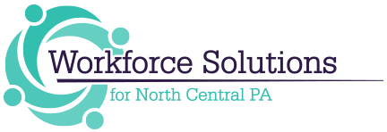

***Workforce Solutions Year in Review***

***We would like to share with you some of the many exciting events that have happened in 2018!***

* ***We were fortunate to welcome new Board Members: Dr. Scott McBride, Mr. Jamie Evens and Ms. Kate Brock to our board this year.***
* ***In July of this year we transitioned to a new provider, ResCare Workforce Services, for our Title I and EARN Programs.  Considering what a significant change this was with a new start-up things went very smoothly.  ResCare had most staff employed and started on July 2, 2018.  For the first quarter, training expenditures have exceeded our established goals; and they have exceeded eight out of nine of the Board's Performance Measures.***
* ***On behalf of MEEA (Manufacturing, Education, and Employee Advancement, Inc.), Workforce Solutions applied for funding from ARC (Appalachian Regional Commission) to complete a Regional Action Plan to address three goals throughout our region:***
* ***Attract people to commute to the North Central PA Region for employment***
* ***Attract people to live in the North Central PA Region***
* ***Attract young people to return and live in the North Central PA Region after post-secondary education***

***The process evolved over several months and included multiple opportunities for community and stakeholder feedback.  The result is a Regional Action Plan with ten priorities for implementation.  Workforce Solutions has committed to ensuring that this plan is implemented in collaboration with our partners.  We have met with all but one county to review the action plan and look forward to working with everyone to make our region a place where people want to live and work.***

* ***As a team, Workforce Solutions staff applied for and received $573,373 to implement the PA State Local Internship Program (PA Slip) in our region. Seventy-five employers provided 158 youth aged 16-24 with quality internship experiences.***

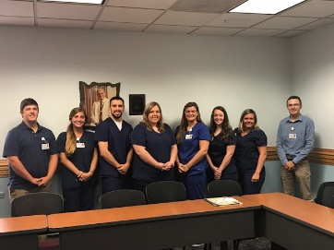 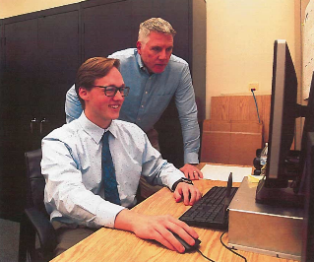 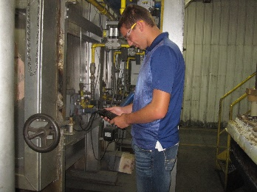

* ***Staff applied for and received Business Education Partnership and Teacher in the Workplace funding to implement programs throughout the region that bring employers, school personnel, and students together. The goals of these programs are to ensure that our schools and students are aware of the career opportunities in our region.***
* ***Staff applied for nearly $2 million in grant funding from a variety of sources including PAsmart, Labor and Industry, Department of Community and Economic Development and the St. Marys United Way. The grant programs include PA SLIP, Next Gen Industry Partnership funding for the Manufacturing, Healthcare, and Building & Construction Industries, and Registered Apprenticeship.***
* ***Staff participated in a Registered Apprenticeship summit along with several partners from our PA CareerLink® system. Following the Summit, staff compiled guidance for the PA CareerLink® partners.***
* ***Staff, in collaboration with several other community agencies, held the 2nd Annual What’s So Cool About Manufacturing Video Contest with 11 schools and employers participating! Staff also started planning for the 3rd Annual Video Contest and have 17 schools and employers participating. Voting for the Viewer’s Choice Award winner will take place March 3-5, 2019 with the Awards Ceremony to be held at the Ridgway Area High School on Tuesday, March 12, 2019 from 6:00pm – 8:00pm.***

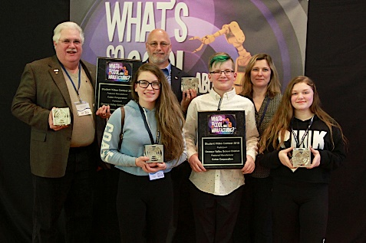

* ***The Youth Committee held an in-school Career Awareness Program Provider meeting to increase the collaboration of program providers working with school districts across our region. The committee plans to hold this meeting each year, expanding the invite list.***
* ***Our Career Counselors have been involved with many schools offering many activities including:***
* ***Career Exploration presentations to Clearfield County students***
* ***Explorer Program presentation to Clearfield Middle School***
* ***Assisted with NOCTI testing and judging an the CCCTC***
* ***Teacher in the Workplace Program***
* ***Collaboration meetings with the DuBois and Clearfield Chambers***
* ***Career Cruises and tours with 10th grade students from Brookville High School***
* ***Industry Day presentations for Brockway and Brookville High Schools***
* ***Job awareness and soft skill building with 10th grade students from Brookville High School***
* ***A new program to reach the elementary students, “Carl the Career Bear” was created in 2018 for our Business and Education Partnership. Carl has visited with employers, has a website and a book to read to elementary school classes.***

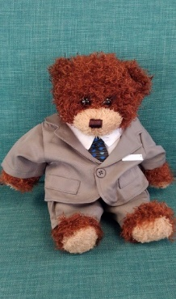 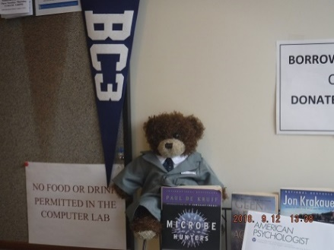

* ***BWDA requested local workforce areas consider assuming responsibility for devices in the career resource centers of the CareerLinks® because they were at the end of their lifecycle.  We requested and received $40,000 and over the summer not only replaced the state computers but also purchased wall mounted TVs for displaying information regarding services, staff, current job openings, events, and success stories on a continuous loop.  Workforce Solutions is now responsible for the technical support of those computers and all Title I and shared devices in the CareerLinks®.  We did a request for proposal and Advanced Computer Solutions (ACS) was awarded the bid for IT support in all seven CareerLinks®.  They implemented a HelpDesk and remote access to troubleshoot issues and work directly with a chosen point of contact at each site.  The new system is working very well and response time is typically within 10 minutes of a reported problem.***
* ***As part of our continuous improvement plan and CareerLink Certification process.  All PA CareerLinks® in our region were visited and reviewed by the Operator and Workforce Solutions staff.  Site Administrators and CareerLink staff, including BWDA, Title I, Veterans, Title II, and OVR participated in the review and provided information to complete the process.  All CareerLinks® continue to improve the delivery system and utilize a customer-centered approach to services.***
* ***In 2017, we implemented a monthly video conference call with Title I staff in an effort to improve communication and provide policy guidance.  In 2018, the “Workforce Spotlight” includes all CareerLink® staff and has evolved into a monthly sharing of ideas and best practices.  Each month a different site discusses innovative ideas and best practices and all participants can ask questions.  Board staff also delivers program and policy information and encourages staff questions and discussion.***
* ***ReadySetWorkPa.com is our latest effort to provide high quality services to customers on their mobile devices or home computers. Because many customers face transportation and childcare issues, are working, or in school, they cannot always get to the CareerLink during normal business hours. The LMC approved the use of performance funds, which we combined with other program dollars to develop a website that would not only provide a gateway to CareerLink services but also serve as a resource for career development, job search and job retention skills.   ReadySetWorkPa.com has links to many useful tools and websites as well as 8 custom designed workshops; and CareerLink staff can monitor customer activities no matter what program they are in.  We have also received positive feedback from area high schools wanting to incorporate this tool into their curriculum for the new Future Ready PA Index they are required to provide.***

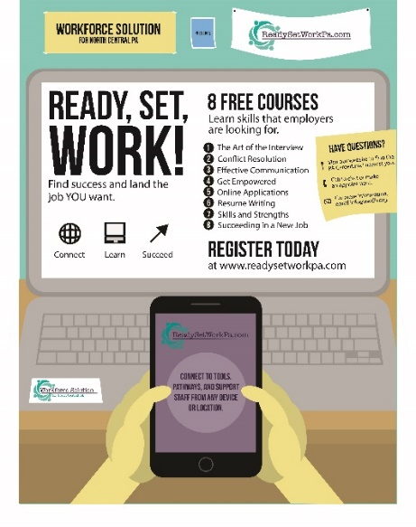

* ***In July of this year, Workforce Solutions assessed the usefulness of the video-conferencing equipment (PolyCom) in the CareerLinks®.  It was determined that the equipment, although initially very expensive, was near the end of its lifecycle and would require a significant investment to make operational again.  Additionally, research indicated that the units were antiquated.   We were able to replace all PolyCom units with Smart TVs combined with small computers, and purchase a ZOOM subscription for far less.  These stations are used to instruct workshops across the region as well as allow for participation in meetings, webinars, and the Workforce Spotlight.***
* ***In 2017, the Clearfield County Careerlink® at Dubois was forced to vacate their space at Penn State campus and relocate to a much smaller space on West Dubois Avenue.  In July of this year Tom Bogacki, Site Administrator, requested that partners in the CareerLink consider expanding into adjoining office space at their location, which would mean an increase in FTEs.  Tom explained that the site could not accommodate any employer events, job fairs, GED testing by IU-10, additional ResCare staff, or potential renters.  The partners agreed, and in August of this year, the Dubois CareerLink® expanded into the adjoining office space of the same building and have since accommodated additional staff and hosted multiple employer events.***
* ***Workforce Solutions in collaboration with Control Chief Corporation, Zippo Manufacturing and several other McKean County employers and the McKean County Economic Development met in late 2017 to discuss the need for employees who are able to skillfully build control panels.***

***On December 20, 2018, nine participants from the region were recognized for completing a 144 hour Customized Electronics and Instrumentation (E and I) Training Program. E and I is a specialized brand of electrical control and electronics that deals with measurement, control and automation of processes.  Most manufacturing companies need employees trained in this discipline.***

* ***Staff had the opportunity to present at a variety of events including:***
  + ***Susie presented at the State WDB Meeting; in Washington DC to the Institute for Educational Leadership; in Pittsburgh at the Autonomous Vehicle Summit; at the PWDA Conference in Hershey, at the Regional Educational Laboratory Meeting in Pittsburgh, at the Bradford Area HR Roundtable, at the Workforce Development Board Symposium in State College,***
  + ***Susie and Pam presented at the Appalachian Higher Education Network (AHEN) in Asheville North Carolina***
  + ***Susie, Joe, and Colleen presented at the Integrated Learning Conference in State College***

***Workforce Solutions staff has had a very busy and exciting 2018 and are looking forward to what 2019 brings!***