

**What’s So Cool About Manufacturing?**

**Workforce Solutions brings partners together for 4th Annual Video Contest**

Eleven schools and eleven manufacturing companies from throughout the counties of Cameron, Clearfield, Elk, Jefferson, McKean and Potter are participated in the 4th Annual “What’s So Cool About Manufacturing?” Video Contest for the region. Each team of 6th through 8th grade students along with a teacher / coach were provided video equipment and training and were matched with manufacturing companies located in the region. The teams created short video profiles of their companies and the career opportunities they offer. By improving the image of these careers and creating awareness for them, the contest not only aims to sustain manufacturing careers, but aims to help them thrive. The event is led by Workforce Solutions (Workforce Development Board serving the North Central PA region)

**The following schools and companies participated in the event:**

Brookville Area School District and Miller Fabrication Solutions®

Cameron County School District and Emporium Hardwoods

Curwensville Area School District and Clearfield Metal Technologies

Clearfield Area School District and Lezzer Lumber Company

Floyd C. Fretz Middle School (Bradford) and Pulakos Chocolates

Kane Area Middle School and Laughing Owl Press Company

Northern Potter School District and The Carpenter’s Shop

Oswayo Valley School District and Napoleon Engineering Services

St. Leo School and Domtar Johnsonburg Mill

St. Marys Middle School and Abbott Furnace Company

Smethport Area School District and Allegheny Bradford Corporation

An award celebration was held on held on March 11th at the St. Marys Area High School to recognize the students, teachers/coaches, and employers. Emcee for the event was Ed Hayden, Director of Employee Relations for Zippo Manufacturing. Carol Kilko, PA Department of Community and Economic Development provided a keynote and a local Dream Team comprised of young professionals working in the manufacturing field shared their journey toward a career in manufacturing! The Dream Team included the following: Stephanie Costanzo, Engineer, Alpha Precision Group; Julianne Inzana, Marketing Coordinator, Abbott Furnace Company and Phil McDonald, Advanced Manufacturing Engineer, Alpha Precision Group

In addition to the Viewer’s Choice Award which goes to the school receiving the most online vote, the following awards were made at the ceremony by a team of 7 judges listed below.

Judges:

Neil Fowler, PA Department of Community and Economic Development (not attending)

Ms. Carol Kilko, PA Department of Community and Economic Development

John Brennan, Penn State DuBois Continuing Education

Jim Chorney, North Central PA Regional Planning and Development Commission (not attending)

Cindy Nellis, Clarion University Small Business Development Center (SBDC)

Matt LaVerde, Intermediate Unit #6

Robert Zaruto, North West Industrial Resource Center

Sponsors for this year’s event included Miller Fabrication Solutions, Domtar-Johnsonburg Mill, Penn Pallet, Horizon Technology, Inc and JIT Tool and Die. The event would not be possible without the generous support of these sponsors. Other funding included grants from DCED and PA Labor and Industry.

The winners of this year’s awards are pictured on the following pages and listed below:

* OUTSTANDING OVERALL VIDEO AWARD - St. Leo School Team featuring Domtar – Johnsonburg Mill
* OUTSTANDING CREATIVITY AWARD - Oswayo Valley team featuring Napoleon Engineering Services.
  + (St. Leo School and Oswayo Valley School have qualified for the statewide contest which

will be held in May via a live streaming event.)

* VIEWER’S CHOICE AWARD - St Marys Area Middle School featuring Abbott Furnace Company.
* OUTSTANDING CAREER PATHWAY AWARD - Smethport featuring Allegheny Bradford Corporation
* OUTSTANDING OUTREACH PLAN AWARD - Cameron County featuring Emporium Hardwoods.
* OUTSTANDING VIDEOGRAPHY AWARD - Fretz Middle School featuring Pulako’s Chocolates.
* OUTSTANDING EDUCATIONAL VALUE AWARD - Clearfield featuring Lezzer Lumber.
* OUTSTANDING TEAM SPIRIT AWARD - Kane Area Middle School featuring Laughing Owl Press Company.

All videos can be viewed at the following link: <https://www.whatssocool.org/contests/north-central-pa/>

The trophies (pictured below on the left) were made by the Precision Machining students at the Clearfield County Career and Technology Center led by instructor Bob Livergood. The students put together a video about Manufacturing that shows them making the awards. Here is the link to the video: <https://drive.google.com/file/d/1Lay_yHABROl_uMSKlTUoJGRlGEjdLo4L/view?usp=sharing_eil&ts=5e67b493>

Awards were also presented to judges, sponsors, the host school and others for their commitment to the program. The awards (pictured below to the right) were made by the Austin Area School District’s PA Wilds Creations Entrepreneur Club.

In addition, banners for the sponsors were made by Jeff Tech.

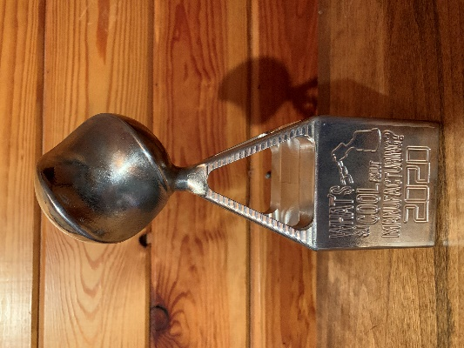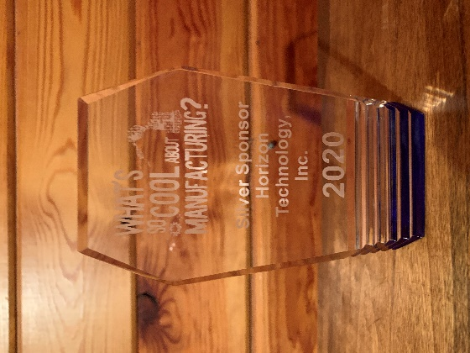

Workforce Solutions is busy planning next year’s event. Manufacturing companies interested in participating next year are encouraged to contact Workforce Solutions.

**Team Pictures of Award Winners:**

Outstanding Overall Video Outstanding Creativity Video

St. Leo School and Domtar-Johnsonburg Mill Oswayo Valley and Napoleon Engineering

Qualified for the Statewide Video Contest Qualified for Statewide Video Contest

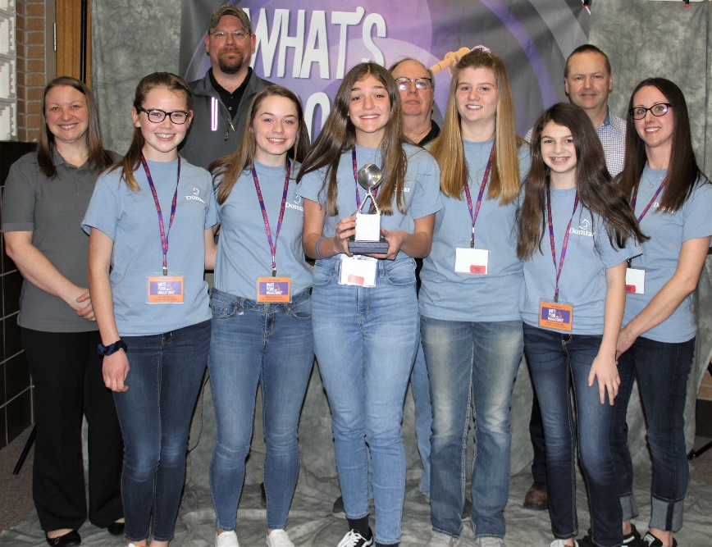 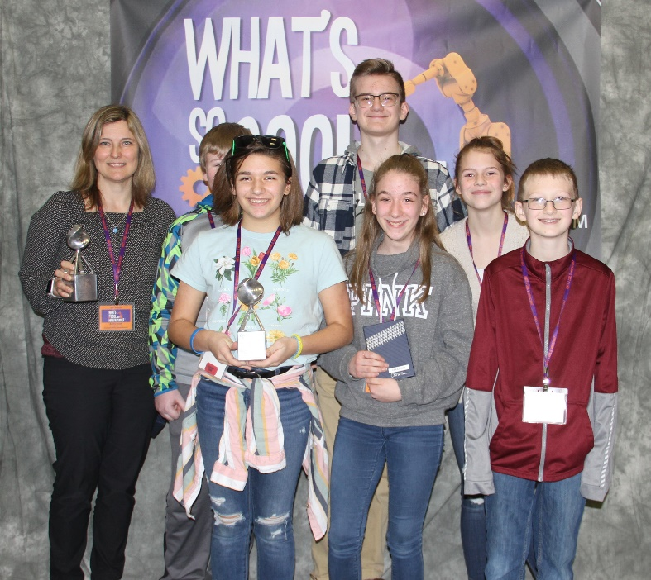

Viewer’s Choice Award Outstanding Educational Value

St Marys and Abbott Furnace Clearfield and Lezzer Lumber

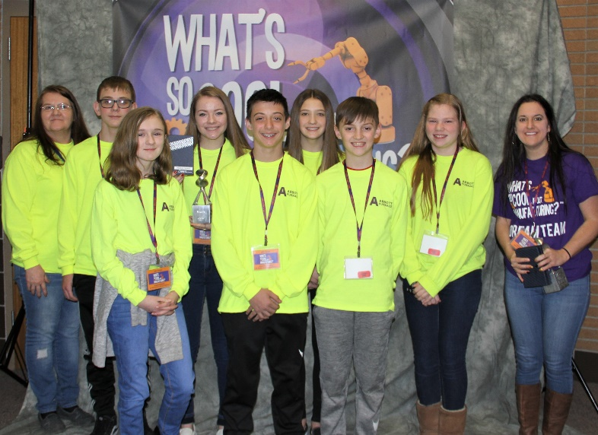 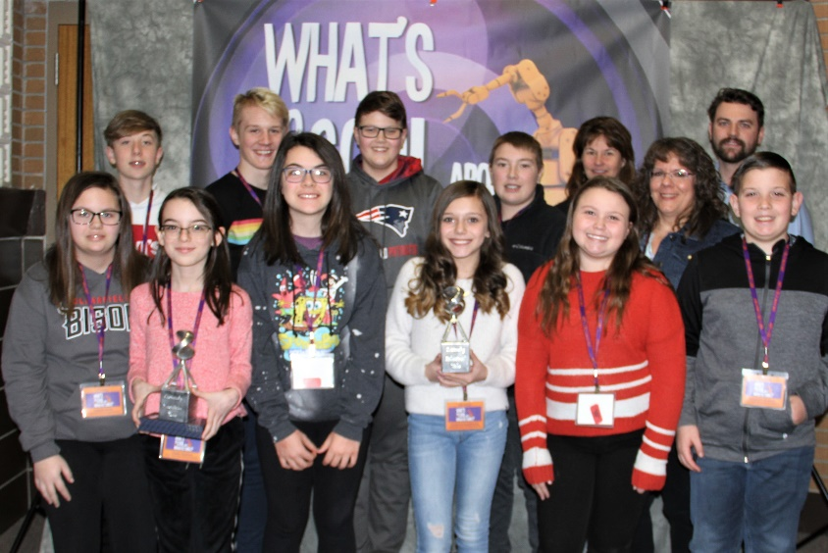

Outstanding Videography Outstanding Outreach Plan

Fretz Middle School and Pulako’s Chocolates Cameron County - Emporium Hardwoods

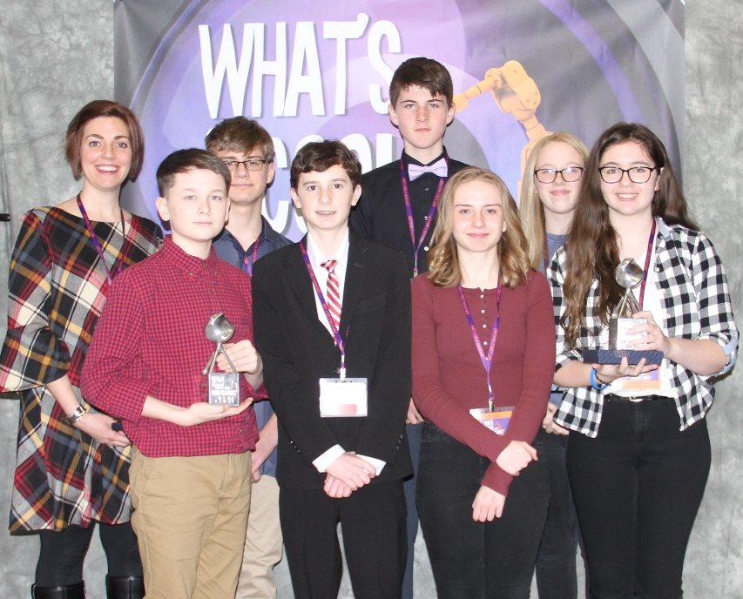 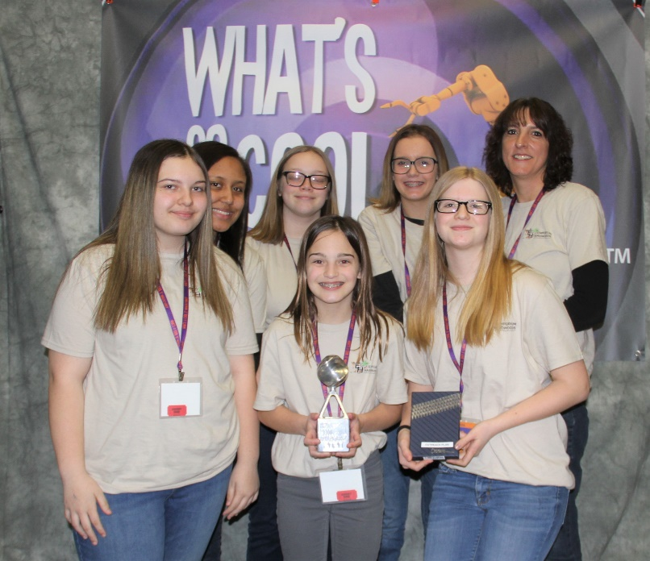

Outstanding Career Pathway Outstanding Team Spirit

Smethport and Allegheny Bradford Corporation Kane and Laughing Owl Press Company

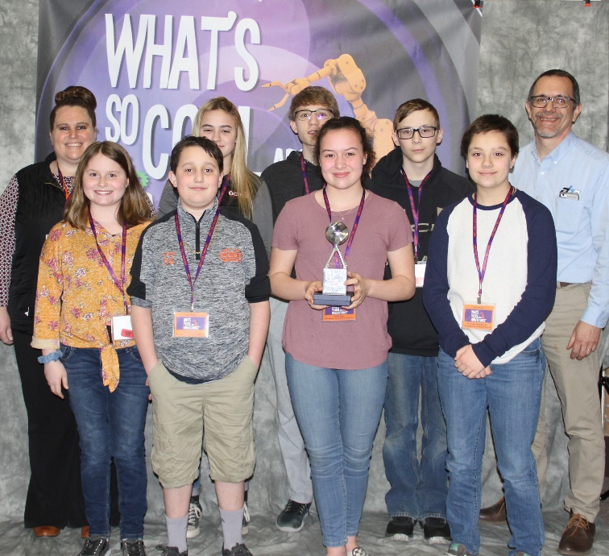 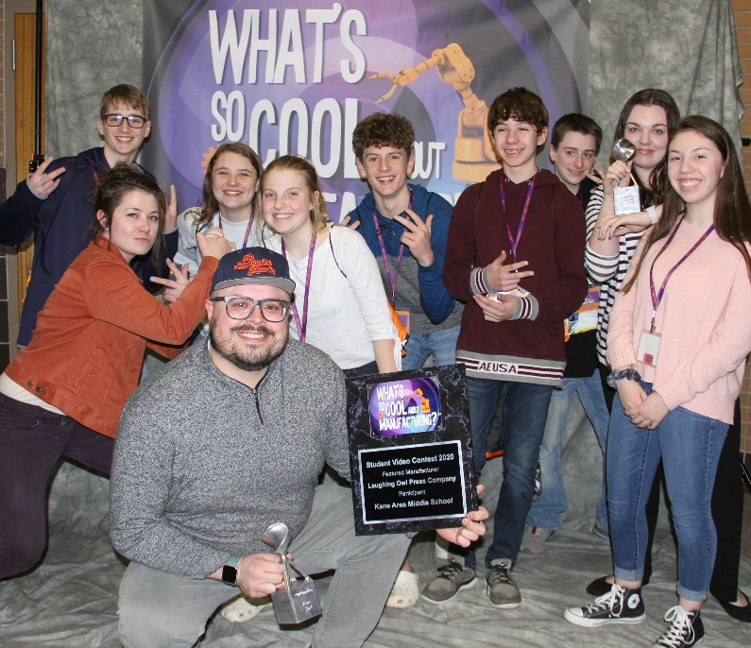

**Left: Emcee:** Ed Hayden, Director of Employee Relations, Zippo Manufacturing Company

**Right-Top: Dream Team Members**: Phil McDonald, Engineer, Alpha Precision Group, Julianne Inzana, Marketing Coordinator for Abbott Furnace Company and Stephanie Costanzo, Engineer, Alpha Precision Group

**Right - Bottom: Special Guest Presenter:** Carol Kilko, Deputy Secretary for Business Finance, Department of Community and Economic Development

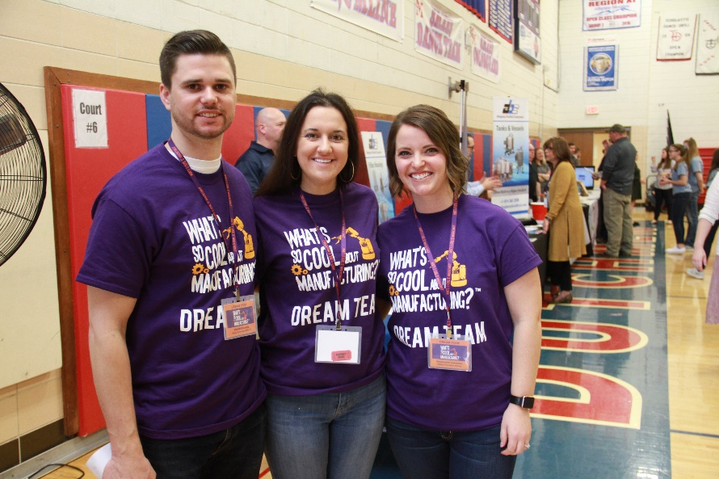

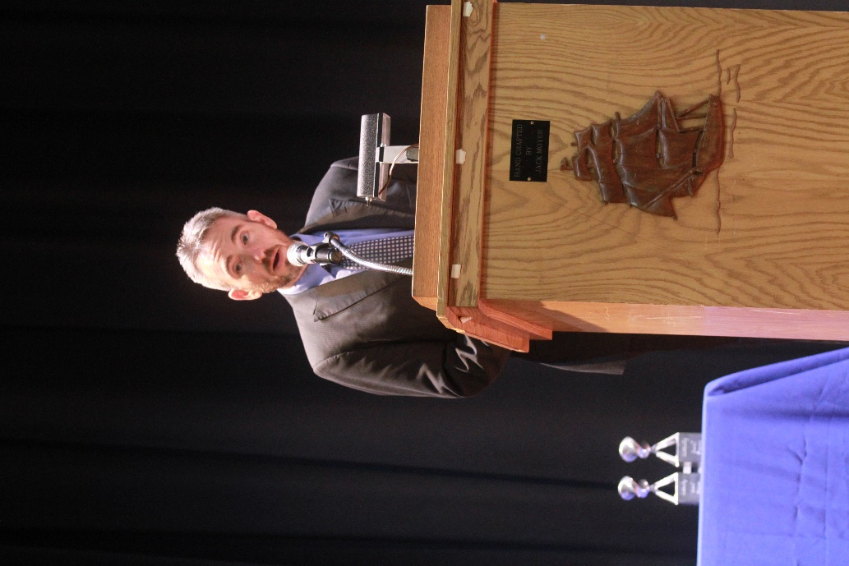

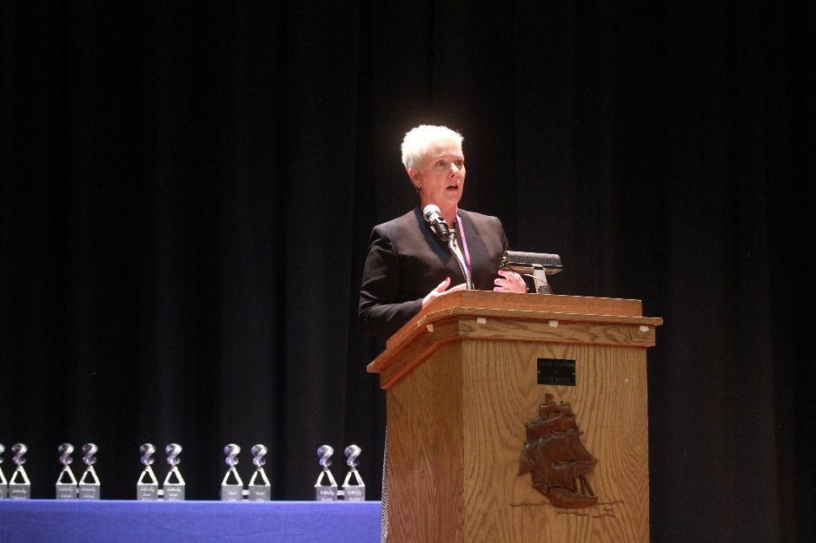

Pictures from Networking Event held prior to the Awards Ceremony

